NEWS RELEASE

Gearing up for food waste collections

Blaby District Council is gearing up to launch new weekly food waste collections as part of the government’s Simper Recycling reforms.

From this week residents will get a bin hanger giving an overview of the service and details of the caddy pack each household will receive during February and March. The pack comprises of a small indoor kitchen caddy and starter roll of liner bags, larger outside caddy and instruction leaflet.

Residents can sign up to a text or email alert if they want to know which week their pack will be delivered: http://www.blaby.gov.uk/foodalert

Food waste will be collected separately from the outside caddy on the same day as refuse and recycling starting from 30 March.

It’s simple to get involved and no amount of food waste is too small to recycle. Simply put food waste into the kitchen caddy lined with a bag – plate scrapings, bones, fruit peelings even uneaten pet food – tie the liner and put it in the outside caddy when a collection is due.

These collections divert food waste from landfill, where it rots, producing methane, a dangerous greenhouse gas 25 times more damaging than carbon dioxide.

Instead, the waste gets processed at an anaerobic digestion plant where it breaks down, generating biogas - cheap and green energy - as well as fertiliser for farmers.

The government suggests the new service will help cut the 18 million plus tonnes of greenhouse gas emissions associated annually with food waste.

Councillor Nigel Grundy, Portfolio Holder for Neighbourhood Services and Assets, said: “Saving food waste from landfill is beneficial both for residents and the environment. It cuts greenhouse gas emissions, boosts recycling and uses the waste to create something useful. This can only be a good thing for everyone.

“Preparing for this new service has been a monumental task and has taken months of planning and hard work from various teams at the Council. We have taken delivery of more than 90,000 caddies and finding places to store them has not been without its challenges.

“Putting the caddy packs together will also take a monumental effort. However, we are fully committed to making this service a success and hope residents appreciate its benefits and support it wholeheartedly.”

For more information on food waste collections visit: https://www.blaby.gov.uk/waste-and-recycling/household-waste/food-waste-collections/

15 January 2025

Best regards  Karen Almond  Communications and Consultation Officer | 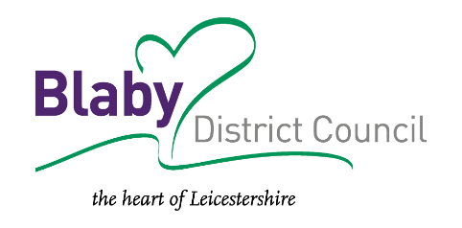
Mob: 07787 947674
Tel: 0116 272 7577
Email: karen.almond@blaby.gov.uk
Web: www.blaby.gov.uk

Keep in touch: www.blaby.gov.uk/signup
Facebook: www.facebook.com/blabydc
Find out what level of service you are entitled to receive by viewing our Service Standards

