ARCHAEOLOGICAL ASSESSMENT of KIRBY MUXLOE VILLAGE

Heritage Environment Record (HER) of Kirby Muxloe Village pre 1699

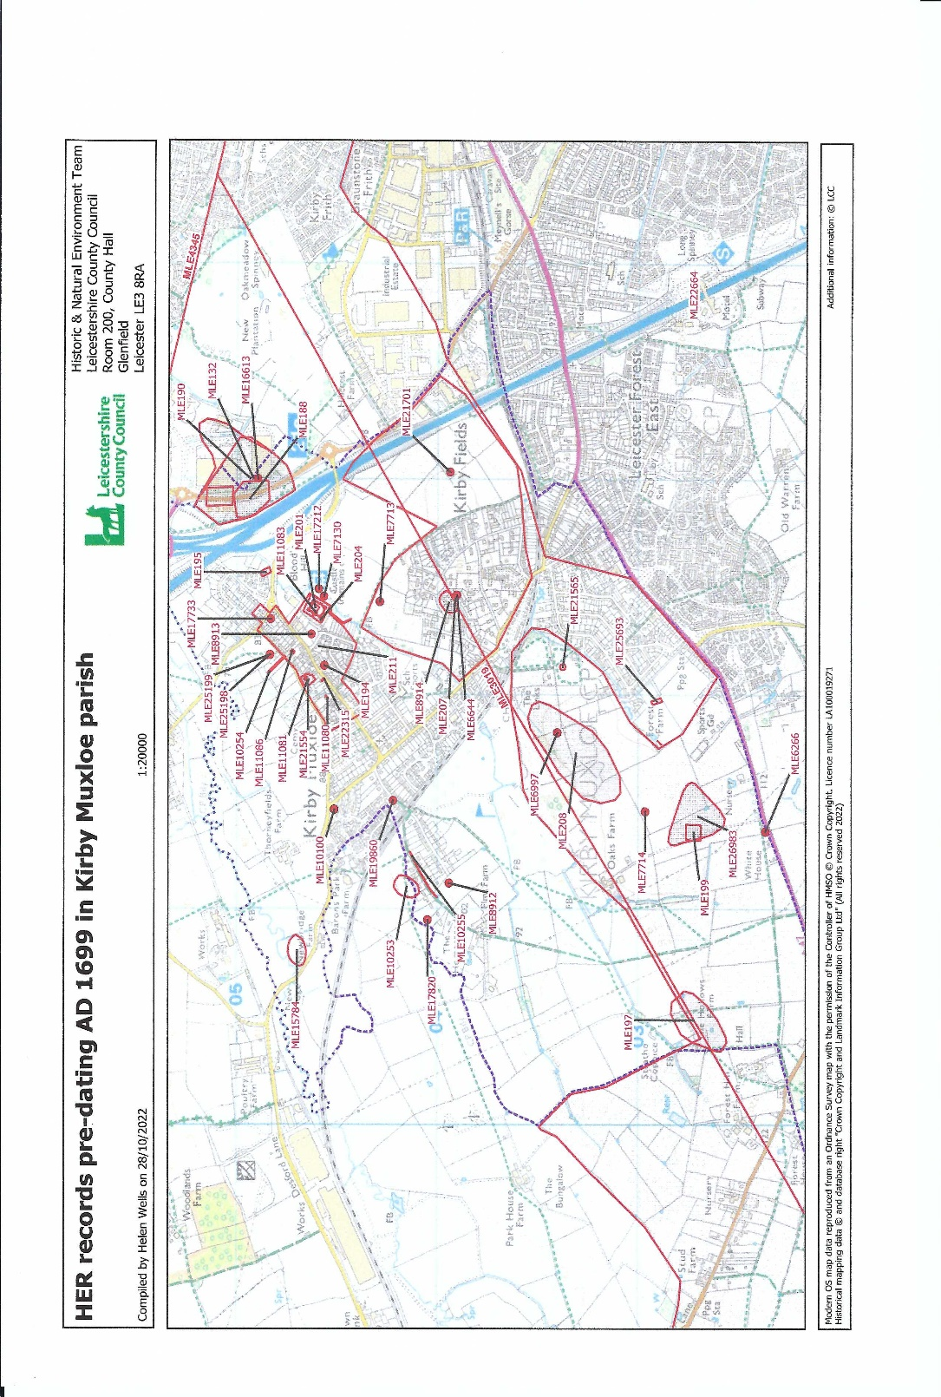
ARCHAEOLOGY of KIRBY MUXLOE

Kirby Muxloe lies in a well-watered situation around 300 feet above sea level and has attracted settlers for many thousands of years. Archaeological evidence of settlement in the village has been unearthed, including finds from the Neolithic, Bronze Age, Iron Age, Roman, Anglo-Saxon and Medieval periods, dating from 3,000 BCE, up to 1539CE.

Prehistoric (to 43BC)

Much evidence from local finds of Neolithic.flint tools show the land was being cleared for agriculture. A Bronze Age copper alloy spearhead dating from 2500 to 801BCE was found in 2005.

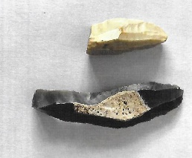
Flint tools found whilst field walking in Kirby Muxloe approx. 3500BCE
Courtesy of Archaeology Warden

Middle to Late Iron Age 400BC to 101BC

A Middle Iron Age settlement was discovered near the junction of land at the M1 junction 21A, in the Glenfield and Kirby Muxloe area and excavations in 2014 found the remains of 25 roundhouses, enclosures, post holes and cremation burials. A unique collection of prehistoric metalwork was discovered including a number of cauldrons, a complete sword, a spearhead, agricultural tools and dress fittings.

Late Iron Age/Early Roman 101 BC to 249C

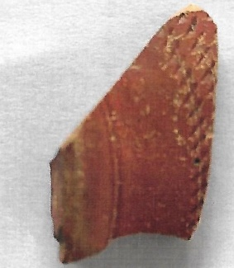

Prior to the redevelopment of “Carmel”, Hastings Road there was an excavation which found evidence of two thirds of a late Iron Age/Early Roman roundhouse and associated finds, dating from 100BCE to 249CE.
A piece of “Samian ware” found in the village - this was high-class domestic Roman pottery
Courtesy of Archaeology Warden

Roman (44AD to 409AD)

Evidence near Oaks Farm of the Mancetter Road running from Leicester to Mancetter near Nuneaton. The road passes through the Kirby Fields area and then through Kirby Muxloe Golf Course. During WWII the R.A.F. took photos of the area. An email was sent to the Senior Planning archaeologist at County Hall by the village archaeology warden in 2017 and the response was that ‘that they would have concerns about the setting of the Castle and potential impacts to buried archaeological remains and that they would be looking for a much reduced scheme retaining the route of the Mancetter Road”.

RAF vertical photographs show a rectangular earthwork site near Oaks Farm. In the 1940’s this still stood in relief, but it now ploughed nearly flat. It is possible that this is a moated site, perhaps the Forest Lodge of Heathley (RAF 541/212 4013).

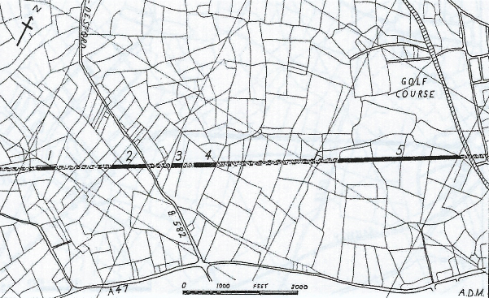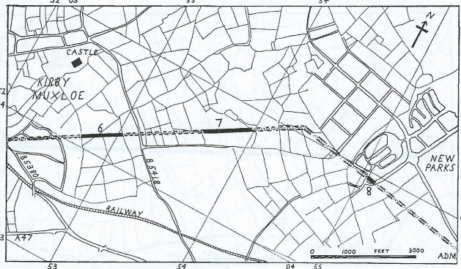

Ref: LAHS Transaction Vol. 42 1966-67 ‘The Roman Road from Leicester to Mancetter’
A. D. McWhirr
The line of the Roman Road in Kirby Muxloe is marked by current day roads and cropmarks.

Anglo Saxon Period 410 – 1066AD

The founding of a settlement by the Danes probably in late ninth/tenth century gave the village its initial name of “Carbi” as mentioned in the Domesday Book in 1086.

Medieval Period 1066 – 1485 AD

The Medieval core of the village centres around the Castle, the Church, Main Street and Desford Road with written evidence from the Domesday Book in 1086 CE showing that early Anglo-Saxon people were living here and in fact gave their name to the village. Many finds have been recorded near the Castle including prehistoric flint tools, Roman coins and brooches. Early medieval coins have been found as well as medieval Papal Bullas which were lead seals attached to documents to guarantee their authenticity. Further information on these finds can be found on the Portable Antiquities Scheme website.The discovery of a medieval gold coin – a Portuguese ‘crusado’ - was found in a garden near the Castle. Also found in the village was a silver half-groat of Edward III, dated to 1367-77.

In 2017 a medieval brooch was found in the area around the castle belonging to Wathes’ farm, by a metal detectorist. There was much speculation in the press in view of the fact that the composition of the brooch was of gold with high-quality enamelling. The British Museum dated it to the 15th century and it is thought it could have been owned by Lady Katherine Hastings, wife of William who was executed by Richard III. The brooch was auctioned by Charles Hanson and was expected to fetch £6,000 to £8,000. There were, in fact numerous bidders, including seven from overseas. The English bidder, who was not identified paid £20,000 to secure the brooch.

Picture courtesy of the Leicester Mercury

During the reign of Edward I, much of the land in Kirby Muxloe was owned by the de Herles family. Some land was sold to the Pakeman family and by the early 14th century they had built a substantial moated manor house where the castle now stands. Lord William Hastings was an important man during the reign of Edward IV rising to the position of Chancellor of England and this land came into the possession of the Hastings family in 1480. William Hastings began work on a fortified castle. He was ambitious and his plan was to build one of the earliest brick-built houses in England and fortify it with embrasures to fire cannons. It is almost unique in that the complete original buildings records still survive. However, the castle was never finished as William Hastings was executed in 1485. The buildings were habitable until after 1630, when a Parliamentary garrison was supposed to be stationed here at the time of the siege of Leicester. For many years the castle was owned privately however, the “Ministry of Works” took possession of the site in 1912 and set about draining the moat and restoring the castle. It is now in the keeping of “Historic England”. Many artefacts were found in the moat and are an important part of the medieval heritage of the county and are cared for by Leicestershire County Council Museum Collections.
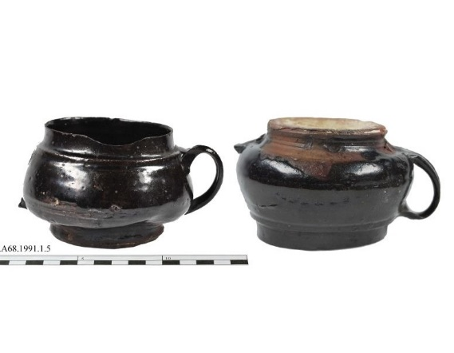

“Cistercian Ware” drinking vessels found in the moat of Kirby Muxloe.

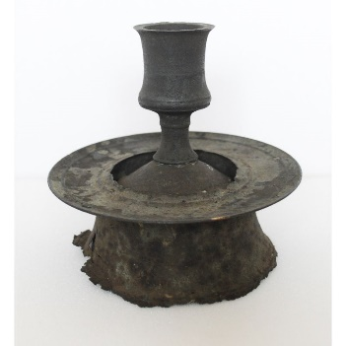
‘High status’ Candlestick found in moat

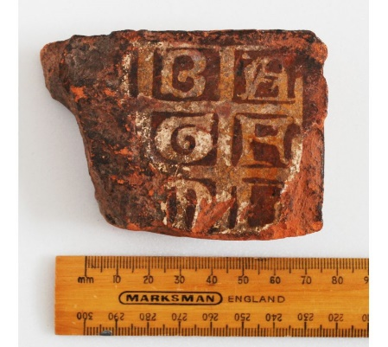

Part of a floor tile from Kirby Muxloe Castle

Photographs: Courtesy of Leicestershire County Council Museum

A farm at the top of Gullet Lane (recorded in 1300) belonged to the Pakeman family and the present-day Elms Farm cottages have part of an original cruck-framed within their structure, possibly dating from this period. Documents dating from 1364 refer to a wood called ‘Le Golet’ which eventually became Gullet Lane. The lane itself dates from 1367 and there is a need to conserve this in order to retain its semi-rural features and the ancient trees and hedgerows.
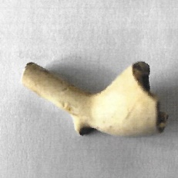
Clay pipe – typically used by farm workers found near Oaks Farm Kirby Muxloe.
Courtesy of archaeology warden

Further evidence of antiquity is the deep ditch which runs approx. 300 yards along the southern edge of the upper part of the lane. It is thought a sand pit on the lane was used to make the bricks for the castle. To the north of Gullet Lane runs an ancient trackway - Portam de Deresforda which formed an important line of communication between Leicester Castle, Desford and Barn Park, through the village and up Blood’s Hill. It is thought this route was used to transport the body of Richard III after his death at the Battle of Bosworth in 1485. It is also the route along which coal from the Swannington Colliery was taken to Leicester from medieval times until the railway line through Kirby was built in the 1830’s.

A medieval deer park - Barons Park - adjoins the lane and still retains a deer leap which was situated on the boundary of the deer park founded by William Hastings.
The early church was a chapelry attached to the ‘Mother’ church at Glenfield.
Recent building work at St Bartholomew’s Church has revealed 13/14th century stonework and the church has a 14/15th century bell tower.
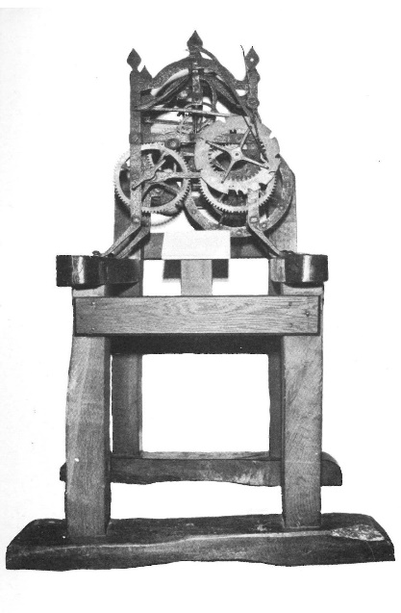
The church originally had a turret clock made in the late 17th century by William Davies of Croft. The clock is still attached to its original oak frame and is early important example of the anchor escapement invented in 1670. No evidence exists that it ever had a dial and the hours were struck by a bell. It is now housed in a Leicester Museum.

Photograph of Turret clock originally situated in St Bartholomew’s Church Kirby Muxloe.
Ref: Article on “The Making of Clocks and Watches in Leicestershire and Rutland” by J. A. Daniel. Courtesy of LAHS Transactions 1951

Post Medieval Period 1485AD -1750AD

In many of the fields bordering the village of Kirby Muxloe there remain earthworks know as “Ridge and Furrow” which are evidence of early farming methods before enclosure of the fields took place in the Post Medieval period. These show the medieval practice of “strip farming” where the villagers were given strips of land to cultivate crops in order to pay tithe to the church and food for their families.

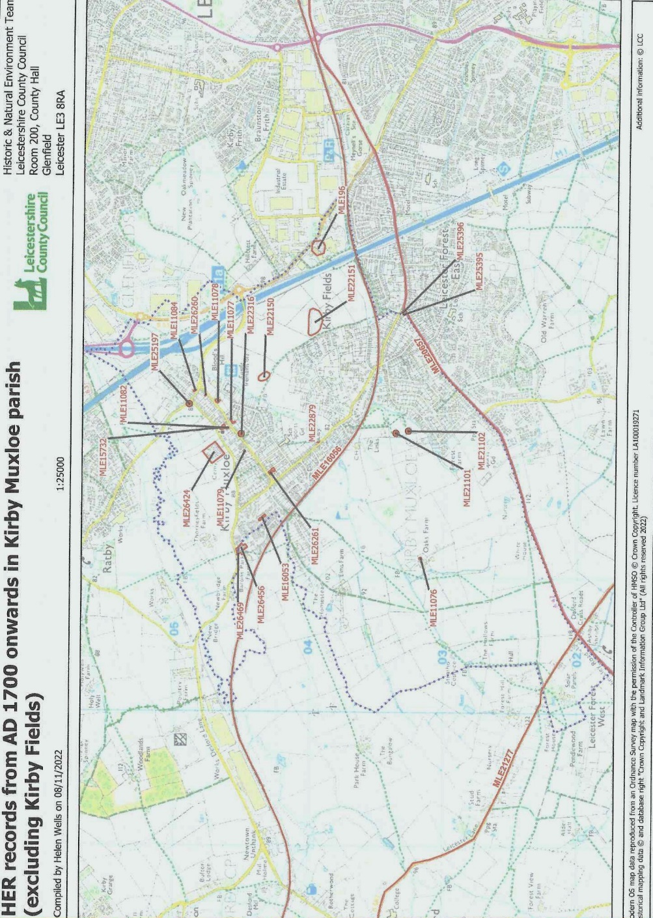

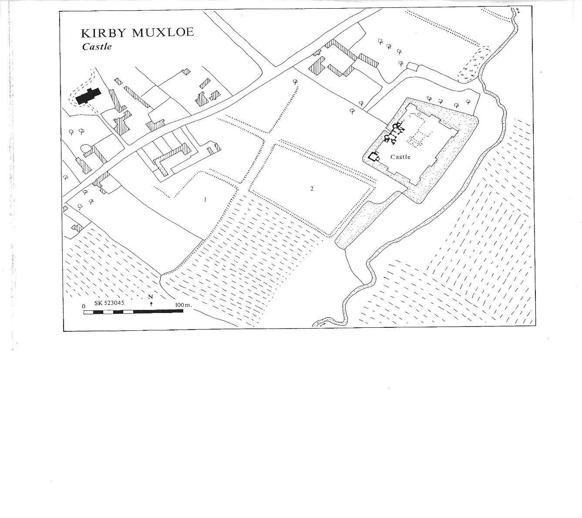

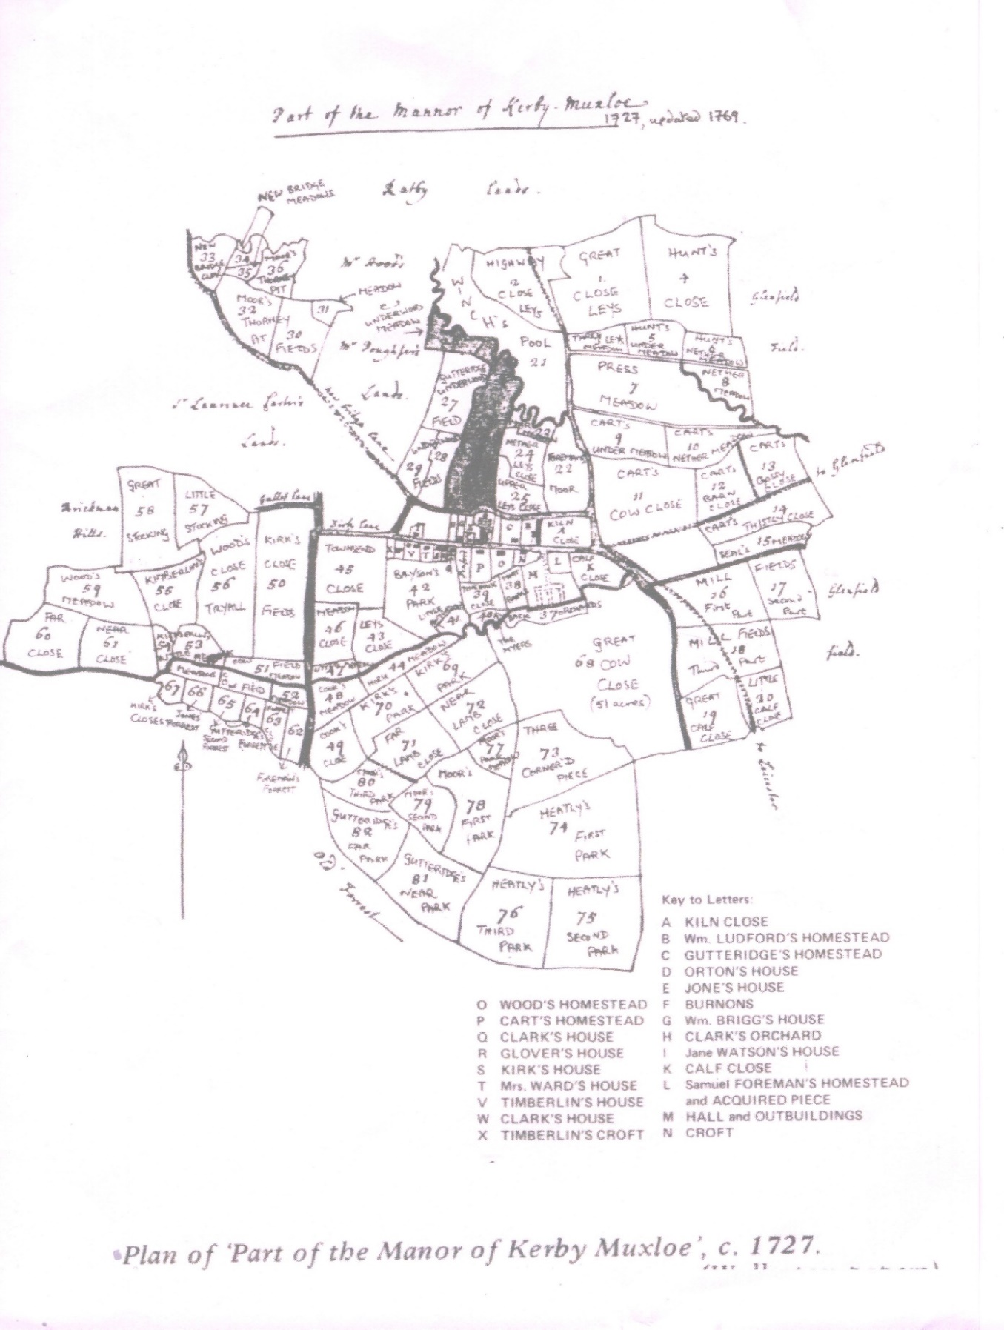
Acknowledgments:

Heritage Gateway - Leicestershire and Rutland Heritage Environment Record.
Archaeologists at Leicestershire County Council Museum Service.
“Old Kirby Muxloe” by Jonathon Wilshere.
Kirby Muxloe Archaeology warden.

