
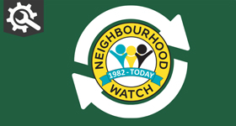 | 

Our News - October 2025
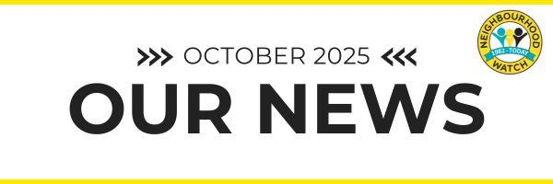
Welcome to the October edition of Our News. As you can see, we've changed the format slightly. Don't worry, I've included the PDF version as an attachment so you can still read it. I'd love to know what you think, please do share your feedback so we can improve.
Neighbourhood Watch annual conference
This year our annual conference was hosted online. Featuring sessions on neighbourhood policing and crime prevention. We shared the charity's new strategy, and celebrated the volunteer recognition awards.
Thanks to everyone who joined, our speakers and our sponsors ERA and SimpliSafe who made the event possible. Find event slides and videos on our website.
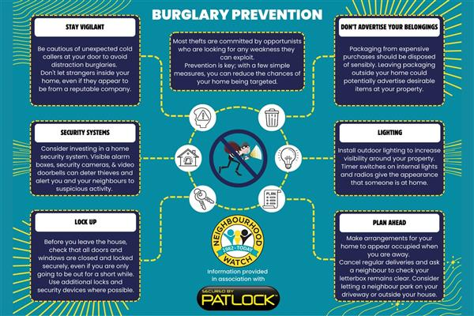
Patlock is the original, patented security solution for secure French doors, patio doors and conservatories, creating the ultimate visual deterrent against intruders. Purchase Patlock at the Neighbourhood Watch discounted price of £42.50. -AD

Mobile phone theft
Statistics show that phone thefts have been increasing, particularly in urban areas. According to the Crime Survey for England and Wales, an estimated 78,000 people had phones or bags snatched from them on the street last year. That is a 153% increase on the number of incidents.
We’ve pulled together information on how to protect your data and what to do if you have had your phone stolen. We are running a mobile phone theft survey to find out what your experiences and concerns are.

Please click here to complete the survey

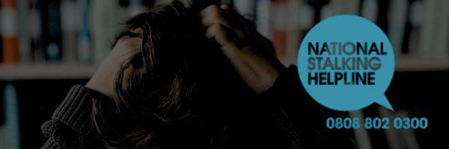
Are you worried that someone might be stalking you?
The Suzy Lamplugh Trust has an online ‘Am I being stalked?’ tool which can help you understand your rights and take the next steps towards safety.
Find out more on the website and reach out to the National Stalking Helpline for more guidance, support and personal safety advice on 0808 802 0300.

Future proof your estate
A crisis rarely comes with warning. Without the right plans in place, decisions about your home, care and family could be taken out of your hands. Wills and LPAs give you control and ensure your loved ones aren’t left powerless.
Click here to see how planning ahead ensures protection is in place. -AD


Doorbell Detectives need you!
BBC One’s hit TV show is back, putting the spotlight on Britain’s Doorbell Detectives capturing neighbourhood crime – and they need you!
Has your smart doorbell helped solve a crime on your street? Have you caught footage of doorstep scammers or parcel thieves, or been alerted to criminals outside your home? If so, get in touch and share your clips and stories to doorbelldetectives@purpleproductions.co.uk or text/WhatsApp: 07386 695 758

As the days get darker, stay one step ahead with AlarmID
Busy commutes. Crowded cafes. A meet-up with friends after work. As autumn sets in, it’s easier than ever to lose sight of your bag - and that’s exactly when thieves strike. AlarmID is a security tamper alarm that protects your handbag, laptop, or backpack from opportunistic theft. If someone tries to take your things — a loud siren instantly sounds alerting you (and everyone nearby). Get yours today with the NW exclusive discount. -AD

Victims of crime have received record compensation from criminal funds
New figures released show that almost £50 million taken from criminals was returned to victims, a 165% increase on the previous year and the highest amount in over half a decade.
This comes as law enforcement recovered almost £300 million in criminal assets. Asset recovery gives law enforcement the tools to track down, and take back, assets gained through criminal activity. Which means that offenders cannot benefit from the proceeds of their crimes. Find the full story on our website.
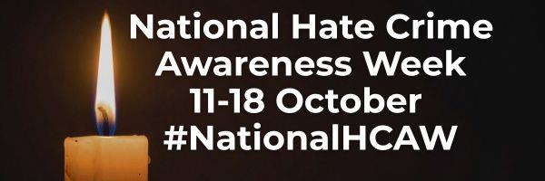
Hate Crime Awareness Week
National Hate Crime Awareness Week runs from 11 to 18 October 2025. The objective of National Hate Crime Awareness Week is to encourage the authorities and communities affected by hate crime to work together to tackle local hate crime issues.
Hate crime is crime targeted towards people because of their disability, faith or beliefs, race, sexual orientation or gender identity, it is vital we work together to eliminate it from our communities Find out more.
Thanks so much for reading, don't forget you can give feedback on the newsletter, I would love to know what you think.
Hope you have have a very happy and safe October.

Attachments
Our News October 2025.pdf

