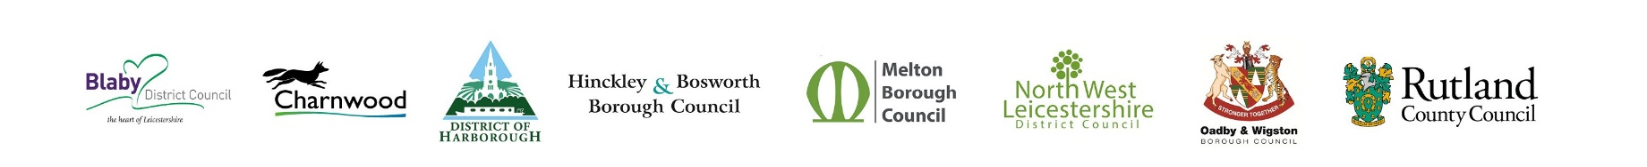

**Media statement**

07/03/25

For immediate release

**Putting communities at the heart of future local government services**

The Leaders of the seven district and borough councils in Leicestershire and Rutland County Council have set out their response following a meeting with the County and City Councils on the 6March.

The Leaders said in a joint statement “It was good to get everyone round the table yesterday to discuss what will be the biggest change in local government for 50 years.

We don’t believe the current system is broken, but the approach of the district and borough councils has always been to work collaboratively for the good of our community, and this will continue. Our focus right now is to establish how best we unlock the benefits of devolution, whilst also ensuring the best way of structuring local government in the area. It is on this latter point where we disagree, and think the idea of one massive council providing all services for the whole of the county is fundamentally flawed, leading to two imbalanced Councils in Leicestershire, and would also fail to realise the benefits of devolution for years to come.

Working as a group of 8 councils, with experience of all council services, we collectively have a very good understanding of what our communities need - whether that's social care, roads, housing, bin collections or leisure - and we believe that three well-balanced councils providing these services is the best solution.

We've requested further meetings with the County and City Councils and will look to reconvene once we receive feedback from government on our interim plans. We will continue to engage with our residents and stakeholders on this important matter so as to ensure that before the November deadline we come up with the best possible proposal for Government to consider.”

For more information, visit one of the district council or Rutland County Council websites.

**ENDS**

**Notes to editors**

Attached with this statement is a graphic depicting the size of the new Councils based on the current proposals.

The leaders of the district and borough councils and Rutland County Council are listed below.

* Cllr Terry Richardson, Leader of Blaby District Council
* Cllr Jewel Miah, Leader of Charnwood Borough Council
* Cllr Phil Knowles, Leader of Harborough District Council
* Cllr Stuart Bray, Leader of Hinckley and Bosworth District Council
* Cllr Pip Allnatt, Leader of Melton Borough Council
* Cllr Richard Blunt, Leader of North West Leicestershire District Council
* Cllr Samia Haq, Leader of Oadby and Wigston Borough Council
* Cllr Gale Waller, Leader of Rutland County Council