Dear all

Please see information below on the LCC scheme for donating unwanted bicycles. Please share this information with your community.
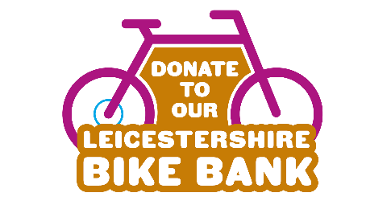
You could use the attached poster for your websites or notice boards.

Families and residents across Leicestershire can now donate your old or unwanted bicycles to our new Leicestershire Bike Bank.

Choose How You Move are collecting bicycles in any condition, for ages 7 and upwards - whether broken, unused, or replaced by new bikes over the holidays - from ‘donation stations’ across the county. Teen and adult bikes are also accepted and will be used for other Choose How You Move initiatives.

Local shops have joined the scheme as ‘donation stations’, to collect bikes at the beginning of January. The dates, times and locations are as follows:

Date | Location | Time
Friday 2 January 2026 | Asda Thurmaston, Barkby Thorpe Lane, Thurmaston, Leicester, LE4 8GN | 10am – 12pm
Friday 2 January 2026 | Tesco Extra, Park Road, Loughborough, LE11 2EX | 1pm – 3pm
Monday 5 January 2026 | Visitor Car Park, County Hall, Glenfield, LE3 8RJ | 8am – 9am
Monday 5 January 2026 | Visitor Car Park, County Hall, Glenfield, LE3 8RJ | 12pm – 1pm
Monday 5 January 2026 | Visitor Car Park, County Hall, Glenfield, LE3 8RJ | 4pm – 5pm
Wednesday 7 January 2026 | Visitor Car Park, County Hall, Glenfield, LE3 8RJ | 8am – 9am
Wednesday 7 January 2026 | Next HQ, Desford Road, Enderby, LE19 4AT | 10am – 12pm
Wednesday 7 January 2026 | Visitor Car Park, County Hall, Glenfield, LE3 8RJ | 12pm – 1pm
Wednesday 7 January 2026 | Joules HQ, The Barn, Rockingham Road, Market Harborough, LE16 7QD | 1pm – 3pm
Wednesday 7 January 2026 | Visitor Car Park, County Hall, Glenfield, LE3 8RJ | 4pm – 5pm

Donation stations at other sites, such as bike shops, will pop up from December 2025 to January 2026. You can find a full list of bike donation stations by searching for the Leicestershire Bike Bank.

The Choose How You Move website has further information if people cannot reach the donation stations. For arranging a home collection, donators can complete an e-form | Active Together. Please note that slots will be limited.

Children’s bicycles will be refurbished and then used for Active Together’s ‘Set, Pedal - Go!’ project from next Spring, lending bikes to school children who don’t have their own so they can learn essential cycling skills alongside their classmates.

By donating old or unwanted bikes, residents can give them an extra lease of life, reduce waste, and make cycling accessible for all children in Leicestershire.

This e-mail and any files transmitted with it are confidential. If you are not the intended recipient, any reading, printing, storage, disclosure, copying or any other action taken in respect of this e-mail is prohibited and may be unlawful. If you are not the intended recipient, please notify the sender immediately by using the reply function and then permanently delete what you have received. Incoming and outgoing e-mail messages are routinely monitored for compliance with Leicestershire County Council's policy on the use of electronic communications. The contents of e-mails may have to be disclosed for requests under Data Protection or Freedom of Information legislation. Details about how we handle information can be found at https://www.leicestershire.gov.uk/data-protection
The views expressed by the author may not necessarily reflect the views or policies of the Leicestershire County Council.
Attachments to e-mail messages may contain viruses that may damage your system. Whilst Leicestershire County Council has taken every reasonable precaution to minimise this risk, we cannot accept any liability for any damage which you sustain as a result of these factors. You are advised to carry out your own virus checks before opening any attachment.

