Hi all

An amber weather warning is in place. Storm Claudia is expected to bring heavy rain leading to flooding and disruption across Leicester, Leicestershire and Rutland during Friday and into Saturday morning, with up to 60 - 80 mm of rainfall possible in some areas. A yellow weather warning for wind and rain is also in place for Saturday.

Prepare and stay informed
- Sign up for flood warnings: GOV.UK Flood Warning Service
- Check for flooding updates: GOV.UK Flood Information, call Floodline on 0345 988 1188, or follow @EnvAgency on X (formerly Twitter).
- Independent Flood Directory: Find flood protection products and services at bluepages.org.uk.
What You Should Do
- Keep a grab bag ready with essentials like insurance documents, medications, and valuables.
- Know how to turn off gas, electricity, and water mains.
- Plan how you’ll move family and pets to safety if needed.
- If you own property next to a watercourse (river, culvert, brook, or stream), read the guidance on your rights and responsibilities:
👉 Owning a Watercourse – GOV.UK
Local Support and Contacts
- Blaby District Council Flooding Page: www.blaby.gov.uk/flooding – includes who to contact and sandbag policy.
- If it’s a surcharging gulley: Call Leicestershire County Council Highways.
- If waste backs up or sewage leaks: Contact Severn Trent Water.
- If a main river is blocked: Contact the Environment Agency.
- If water poses a threat to life: Call the Fire Service (Leicester, Leicestershire and Rutland Resilience Forum will assist with accommodation if needed).
- For full details on who to contact and actions to take before and during flooding:
👉 LLR Resilience Forum – Flooding Advice

Please encourage residents to prepare in advance for potential flooding and not rely solely on Council assistance.

The Council has very limited resources and may not be able to support areas if widespread flooding occurs. Residents should take steps to protect their own properties wherever possible, including:

- Stocking up on sandbags and flood protection materials in advance
- Planning ahead for how to keep themselves and their families safe

Our sandbag supply is extremely limited and will only be allocated to help:
- Protect life and critical infrastructure (such as hospitals or substations)
- Support elderly, disabled and vulnerable residents
- Maintain access for emergency vehicles

Sandbags can be purchased from local DIY stores or building merchants. Residents can also consult the Bluepages Independent Flood Directory for flood defence products.
Other useful resources include how to prepare your home and make a personal flood plan and a householder’s guide to flood recovery.

Regards  Julie Hutchinson  Communications, Consultation and Digital Services Manager | 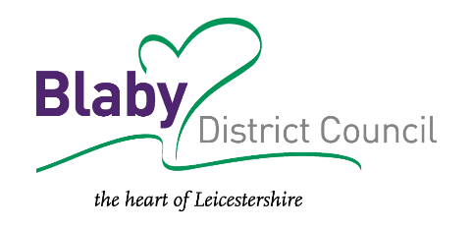
Tel: 0116 272 7648
Email: julie.hutchinson@blaby.gov.uk
Web: www.blaby.gov.uk

Keep in touch: www.blaby.gov.uk/signup
Facebook: www.facebook.com/blabydc

I work flexible hours and may work outside of normal office hours. I don’t expect an
immediate response to my email, so please respond at a time convenient to you.
Find out what level of service you are entitled to receive by viewing our Service Standards

